COMPUTERIZED MEDICAL EQUIPMENT AND DEVICES MANUFACTURES INDUSTRY LTD
BUSSINESS PLAN
STARTUP PLAN
Ahmad Sani K
12/2/2017

CMED NIGERIA was design to manufacture, upgrade the existing laboratory equipment with noise and built-in battery and sells other medical company product

1.0 Executive Summary 1

1.1 Mission 1
Chart: Highlights 2
1.2 Keys to Success 2
1.3 Objectives 2
2.0 Company Summary 3
2.1 Start-up Summary 3
Table: Start-up Funding 4
Chart: Start-up 5
Table: Start-up 5
2.2 Company Ownership 6
2.3 Company Locations and Facilities 6
3.0 Products 6
3.1 Product Description 7
3.2 Competitive Comparison 11
3.3 Sales Literature 11
3.4 Sourcing 11
3.5 Technology 12
3.6 Future Products 12
4.0 Market Analysis Summary 12
4.1 Market Segmentation 13
Chart: Market Analysis (Pie) 13
Table: Market Analysis 13
4.2 Industry Analysis 14
4.2.1 Competition and Buying Patterns 14
4.2.2 Main Competitors 15
4.2.3 Industry Participants 15
4.2.4 Distribution Patterns 15
5.0 Strategy and Implementation Summary 15
5.1 Marketing Strategy 15
5.1.1 Promotion Strategy 16
5.1.2 Pricing Strategy 16
5.2 Sales Strategy 16
5.2.1 Sales Forecast 17
Table: Sales Forecast 17
Chart: Sales Monthly 17
Chart: Sales by Year 18
5.2.2 Sales Programs 18
5.3 Milestones 19
Table: Milestones 19
Chart: Milestones 19
6.0 Management Summary 20
6.1 Organizational Structure 20
6.2 Management Team 20
6.3 Management Team Gaps 22
6.4 Personnel Plan 22
Table: Personnel 22
7.0 Financial Plan 23
7.0 Financial Plan 23
7.1 Important Assumptions 23
Table: General Assumptions 23
7.2 Key Financial Indicators 24
7.2 Key Financial Indicators 24
Chart: Benchmarks 24
7.3 Break-even Analysis 25
Table: Break-even Analysis 25
Chart: Break-even Analysis 25
7.4 Projected Profit and Loss 26
Chart: Gross Margin Monthly 26
Chart: Gross Margin Yearly 26
Table: Profit and Loss 27
Chart: Profit Monthly 28
Chart: Profit Yearly 28
7.5 Projected Cash Flow 29
Table: Cash Flow 29
Chart: Cash 30
7.6 Projected Balance Sheet 31
Table: Balance Sheet 31
7.7 Business Ratios 31
7.7 Business Ratios 31
Table: Ratios 32
Table: Sales Forecast 1
Table: Personnel 2
Table: Personnel 2
Table: Profit and Loss 3
Table: Profit and Loss 3
Table: Cash Flow 5
Table: Cash Flow 5
Table: Balance Sheet 6
Table: Balance Sheet 6

1.0 Executive Summary
C.M.E.D, Corp. is a medical device development company that intends to design, patent, and market medical devices related to medical laboratory equipment and devices niche markets. Two devices have already been designed with the participation of leading physicians and scientists in medical laboratory. Seven patents are initially incorporated. The company projects N6 billion in sales in year three. The company expects to have N 17 billion in revenue by year five. Patent applications on its first three market entries have already been accomplished using a top patent law firm.
The market segments are clearly defined and all are subject to a high growth trend. One market is projected to exceed N 55 billion in the next three years. That is the laboratory equipment and devices market. One of the founders of C.M.E.D. participated in the design of the current market leader in that field and has improved upon the product significantly. Another market addresses a well-defined and unanswered need in Laboratory equipment and devices: the clearing of liquid sample and determination of erythrocyte volume in blood Laboratory procedures. A new and innovative design has been created to answer the needs of scientist.
This market should begin at N 7 billion but could expand to several hundred billion as soon as approvals are obtained for many varied laboratory procedures. C.M.E.D intends to license this technology to a larger company. The company becomes mature in year three. The company is potentially profitable in year one only if a proposed licensing agreement can be closed.

1.1 Mission
The mission of C.M.E.D, Corp. is to design, develop, and market new patented technologies in the medical device field. The technologies will fill market niches that each account for a minimum of $7 billion dollars in potential sales. Each technology will fill a current need in medical procedure by improving upon an existing technology or device, or by designing a device to serve a need that is clearly defined and acknowledged by medical professionals. Each product shall be priced to appeal to a managed-care market that stresses lowest cost of total treatment parameters.

Chart: Highlights
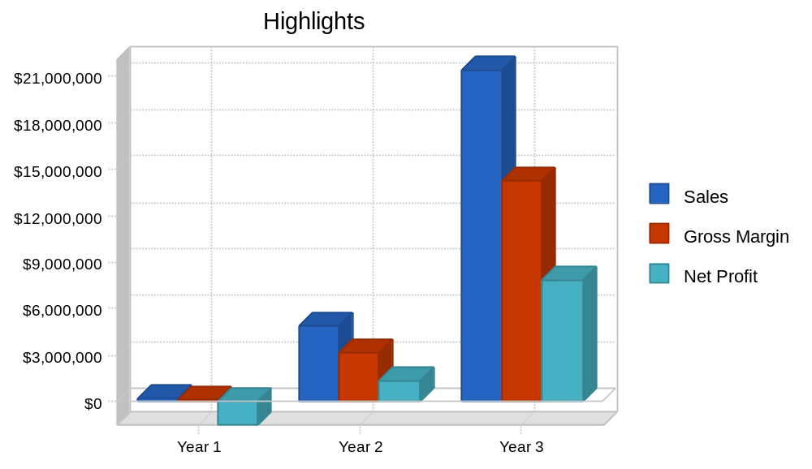

1.2 Keys to Success
The keys to success for C.M.E.D, Corp. are as follows:
- Initial capitalization obtained.
- All patent applications filed.
- The ability to generate early revenue from non-regulated markets in Africa.
- Licensing at least one technology and application to a major medical device corporation.
- Getting low interest loans and/or grants to fully fund product development and prototype manufacture.
- Recruiting top-notch CEO prior to second round financing and market roll-out.

- Successful implementation of sales and marketing plan to Nigeria, Niger, and U.S managed care market to obtain a minimum 10% market share in the second full year to generate N 7 Billion in revenue.
- Increased product development and continued market share gains to produce an N 17 Billion revenue company by year five.

1.3 Objectives
The principal objectives of C.M.E.D, Corp. are as follows:
- To achieve a 10% market penetration in the Laboratory Equipment market by year three.
- To achieve N 6 billion in revenue by year three.
- To raise N 350 million in private seed capital in the first six months.
- To win low interest loans and grants from the government of Katsina state, Nigeria totaling N 380 million in year one.
- To license its technology for centrifuge/Hematocrit centrifuge market for N350 thousands in year one.
- To convert all existing AC current laboratory machine to DC current with high standard of security and protection

2.0 Company Summary
C.M.E.D, Corp. will develop and market medical equipment and devices through multiple distribution channels both foreign and domestic. The company is currently developing its patent-applied technologies to final product and approval stage. It is also seeking to establish its corporate identity in the medical products field. Growth strategy calls for one joint venture license as well as the following objectives:
- Complete the patent process.
- Establish corporate identity, brand names, trademarks.
- Establish a medical advisory board.
- Build staff, infrastructure, and retain consultants for trial and compliance issues.
- Conduct a trial.
- Continue R & D and product development.
- Explore options for 2nd round financing (venture capital, corporate alliance, licensing, and public offering) to maximize value to shareholders.

2.1 Start-up Summary
The key elements in the Start-up plan for C.M.E.D, Corp. are:
- The legal expense for filing all patent applications.
- The establishment of Corporate Identity.
- The location and place of doing business.
- Funding of additional capital raising alternatives.
- Salary for the two key managers and founders.
- Formulation of Strategic Plan. Costs of raising capital through private placement.
N 20, million was raised from the initial two investors for these purposes. This funding came in in 2017 and these tasks have either been completed successfully or are in the final process of completion. These are treated purely as start-up expenses by this plan. N 5, million is treated as cash-on-hand as of the start of this plan on January 19, 2017. The remainder of the start-up capital required as well as capital required for the continuation of operations in the first six months will be provided by selling the shares in the private placement. The capital obtained from these sales is expected to total an additional N 400, million and the plan calls for this cash to be infused in May and June, 2017.

Table: Start-up Funding

Start-up Funding
Start-up Expenses to Fund | N46,000, 000
Start-up Assets to Fund | N45,000, 000
Total Funding Required | N91,000, 000
Assets
Non-cash Assets from Start-up | N0
Cash Requirements from Start-up | N45,000, 000
Additional Cash Raised | N0
Cash Balance on Starting Date | N45,000, 000
Total Assets | N45,000, 000
Liabilities and Capital
Liabilities
Current Borrowing | N0
Long-term Liabilities | N0
Accounts Payable (Outstanding Bills) | N0
Other Current Liabilities (interest-free) | N0
Total Liabilities | N0
Capital
Planned Investment
Investor 1 | N53,000,000
Investor 2 | N23,000,000
Investor 3 | N11,000,000
Investor 4 | N5,000,000
Additional Investment Requirement | N0
Total Planned Investment | N92,000,000
Loss at Start-up (Start-up Expenses) | (N46,000,000)
Total Capital | N45,000,000
Total Capital and Liabilities | N45,000,000
Total Funding | N92,000,000

Chart: Start-up
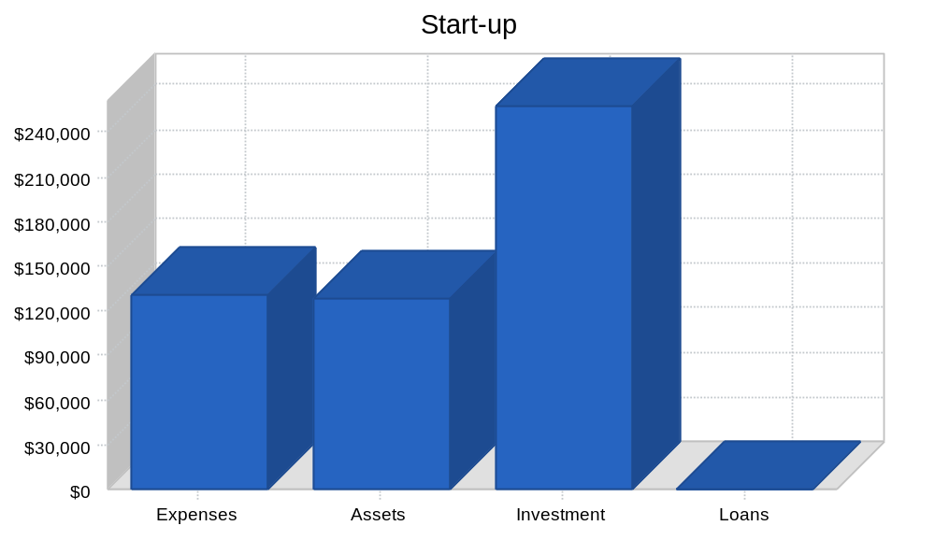

Table: Start-up

Start-up
Requirements
Start-up Expenses
Legal | $50,000
Stationery etc. | $2,000
Consultants | $3,000
Insurance | $3,000
Rent | $9,300
Custom CAD software | $5,700
Logo Design | $1,000
Management Salaries | $56,000
Total Start-up Expenses | $130,000
Start-up Assets
Cash Required | $128,000
Start-up Inventory | $0
Other Current Assets | $0
Long-term Assets | $0
Total Assets | $128,000
Total Requirements | $258,000

2.2 Company Ownership
CMED, Corp. is a North State "C" corporation.
Its founding shareholders are:
Ahmad Sani K (2,545,000 shares)
Abubakar Sani(500,000 shares)

2.3 Company Locations and Facilities
Company location and facilities for CMED Corp remains to be developed.

3.0 Products
CMED, Corp. will initially market two distinct products.
- The Laboratory centrifuges, work by sedimentation principle, where the centripetal acceleration is used in separate substances of greater and lesser density.
- The Hematocrit centrifuge, used for determination of volume fractions of erythrocytes in blood.
The technology used in these products is the subject of seven patents in the application process.
These two product areas may be more generally defined as follows:
- Centrifuges: is a piece of laboratory equipment, driven by a motor, which spins liquid sample at high speed. Also it is used for the separation of fluids, gas or liquid, based on density.
- Hematocrit centrifuge: is used for determination of volume fractions of erythrocytes in blood for diagnostic purposes and doping tests. Also it is used to derive plasma for the photometric determination of the bilirubin content of the blood of neonates.

3.1 Product Description
A detailed and technical description of the CMED, Corp. initial product line follows:
Laboratory Centrifuge
Application is Modern centrifuge device which will used battery to spins a liquid sample by separation of fluids, gas or liquid, based on density at standard speed.
Scope: This innovation applies to the internal technology of centrifuge. Visi-Band is a pre-loaded delivery device for applying multiple ligating bands remotely from the distal tip of an endoscope. (The leading current product in this category is the Speedband made by Boston Scientific).
Clinical Advantages: A perceived clinical advantage of these bands is ligation of a greater range of tissue sizes with a single band. These ligating bands stretch easily over the largest tissue to be ligated and yet will grip securely even the tiniest tissue to be removed. These bands can have an inner diameter near zero so that even tiny varices are gripped firmly.
Current State of the Art Technology: Market-leading bands today are molded of homogeneous rubber materials. Material properties of elasticity have limited the stretch of conventional ligating bands to a range of about seven-fold. A typical market-leading band for esophageal variceal ligation has an inner diameter of 1.8mm. This band can stretch to a maximum inner diameter of 12.4 mm to ligate a varix. This maximum size roughly corresponds to the endoscope diameter. A varix of 1.8 mm would not be ligated because the band would be loose around the tissue.
CMED Technology: The Super-Elastic Band innovation effectively engineers the band material stresses in a way that increases the apparent stretchability of the band many times. We have created bands with proximate zero inner diameters, which can be stretched at least as large as conventional bands with large inner diameters. Bands created with this technology can also hold their elasticity for longer periods of time. The basis of our technology is an internal compressive pre-stress at the band inner diameter. This can be achieved in at least five practical ways covered in our patent documentation. The true zero inner diameter band is a result of the compressive forces creating small scale creasing or wrinkling which fill the band interior. Bands made to date exhibit an effective elasticity of 20 times and more versus the seven times stretch in the market-leading band.
CMED laboratory devices should have an unprecedented and superior range of application to meet ligation requirements. Super-Elastic Bands can mean fewer special sized devices to manufacture, purchase, specify, and stock. This fits well in a managed-care environment through lower costs with inherent clinical advantages. Medquip and the health care system could benefit from higher volumes of a smaller number of different products.
Further Clinical Advantages:
Remain to develop
Summary of advantages over currently available products:
- Better visibility due to side-mounting of band dispensing device.
- Smaller band, more stretch, enabling banding of smaller varices.
- Internal loading of ETA container, enabling protection (ETA container are not dislodged).
- Capable of carrying more bands (8 vs. 6).
- Significant reduction in manufacturing and assembly costs.
Hematocrit Centrifuge
Application is determination of volume fraction of erythrocyte in blood. Current solution employ plastic tube, battery which control remotely
Scope: An uncleared fundal pool of retained blood in the stomach precludes complete visualization of the stomach in 5.6% of cases of acute upper gastrointestinal bleeding. According to an October 1997 article in Gastrointestinal Endoscopy: "In conclusion, the results of this study provide evidence that the inability to clear a fundal pool of blood at the time of emergent upper endoscopy for acute UGI bleeding is associated with substantial morbidity and mortality and ... Aggressive mechanical and/or pharmacological measures to clear the fundus of blood are warranted in patients undergoing urgent endoscopy for acute UGI bleeding."
Clinical Advantages: The Visi-Gator tool may be inserted from the outside into the biopsy channel of the endoscope as needed. The scope does not need to be withdrawn to install and use the Visi-Gator.
Current State of the Art Technology: Lavage with suction is frequently ineffective due to clot integrity and clogging of suction channels. High-pressure water jets penetrate beyond the clot, potentially penetrating and damaging soft tissues.
Medquip Technology: Visi-Gator is a thin, ultra-flexible, spring-like device that is introduced through the biopsy channel to the distal end of the endoscope. High-speed rotations of one or more of many concentric spiral elements both drive rotating lysing filaments and positively pump solids and liquids out. Centripetal force expands and stiffens the filaments from a stored position during insertion to a generally planar and circular path. Vacuum may also be applied. A hollow central channel may also be provided for irrigation, access, or other therapy.
Further Clinical Advantages:
- Visi-Gator clot dissolving aggressiveness varies from mild to intense and is proportional to the adjustable input speed control.
- Visi-Gator actively draws fluid and solids up through the biopsy channel with a positive pumping action.
- Visi-Gator continues to dissolve solids even as they pass through the biopsy channel.
- Visi-Gator will tend to be non-clogging and self-cleaning.
- Visi-Gator does not rub high-speed surfaces against the biopsy channel and cause high rates of wear.
- Visi-Gator provides a central channel for clear water irrigation, additional suction or other therapy.
- Visi-Gator motor driver is envisioned to be reusable. The fluid path and lysis head is likely to be disposable.
- Visi-Gator dissolving action and lysing head is transparent. One can see through the scope real time in the zone of clot lysis continuously as the lysing progresses.
- Visi-Gator appears to be capable of rapid clot lysis yet is gentle to tissue.
- Visi-Gator tip is soft and pliant to flex over any non-clot tissues.
- Visi-Gator lysis zone is generally a defined planar disc perpendicular to the axis of the distal end of the scope.
- Visi-Gator allows lysis not to penetrate beyond the disc boundaries.

3.2 Competitive Comparison
The leading product currently available in the endoscopic variceal ligation market is the Speedband made by Boston Scientific. Other product entries are from C.R. Bard and Wilson-Cook. The Speedband from the Microvasive division of Boston Scientific is far and away the market leader with an estimated 60% market share. The Six Shooter from Wilson-Cook has a 20% market share. Rapid-Fire made by C.R. Bard has a 10% market share. All of the devices are disposable (single patient use).
Eric Smith, a founder of Medquip and the developer of Medquip's patented technologies had significant participation in the design of the Speedband. He is aware of both its strengths and shortcomings. The Visi-Band is a much improved product in a rapidly growing market application. Many of the product advantages were highlighted in the previous section of this plan. To summarize the key advantages:
- Band itself enables smaller varices to be banded.
- Smaller hole plus more stretch in band.
- Device has better field of view.
- Device has better mobility.
- Bands are fired internally vs. externally.
- Significant cost reductions in mfg.
The Visi-Gator and the Visi-Lyser represent an entirely new application with no current competition. Their use can potentially range from stomach procedures to heart procedures and a variety of other surgical procedures. Together they solve the well documented and acknowledged problem of lack of visibility in endoscopic procedures where blood clots are involved. The Visi-Lyser also allows an improved and more efficient means of removing fundal pools of clotted blood and tissue.

3.3 Sales Literature
Sales literature for CMED, Corp. remains to be developed.

3.4 Sourcing
Primary raw materials needed for Medquip products are as follows:
- Molded plastic parts.
- The tooling and molds (capital expenditure).
- Band material (polymer).
- Small electric motor.
All of these components are easily sourced and multiple suppliers have been identified. In addition, injection molders have been identified to manufacture the molded components for Medquip products. There are multiple potential sources.
A potential source for additional research and design help and compliance is Valnet in Puerto Rico.
Medquip will perform final assembly and distribution from its own facility in Puerto Rico or utilizing contract manufacturing depending on the extent of financial support from the government of Puerto Rico.

3.5 Technology
Sidley and Austin is patent attorney for Medquip, Inc. Seven patents have been authored and filed. All patents take into account both offensive and defensive postures in their claims. Opinion of legal counsel is strong and firm that all of Medquip's patent applications are enforceable and defensible.
The principal areas (general descriptions) of the patents applied for are as follows:
- The ligating band itself.
- The movable dispenser.
- The dispenser itself.
- Two additional alternative dispensers.
- The tissue dissolving device.
- The transporting catheter.
- The dispenser control device.
Care has been taken to take into account all potential claims of the inventions as well as to protect them from possible competition from other technologies (including inferior ones). All patent application documents are available for examination by potential investors. The first document is entitled "A ligating structure having greater stretchability, greater shelf life, and greater ligating characteristics and method of manufacture." It lists more than 40 independent claims.
Also available is the assignment of all patents in the medical device field (above listed and future developed) by Eric Smith to Medquip, Inc. The first four patents listed above relate to the Visi-Band. The last two relate to the Visi-Gator.
Trademark application has been filed on the name Medquip. Trademark applications are in process on the names Visi-Band, Visi-Gator, and Visi-Lyser. No conflicts or other use of these names has been found in an initial search.

3.6 Future Products
Plans for future development by CMED include additional ideas and technologies to be created by Abubakar Sani as PM for CMED. In addition CMED may seek to acquire technologies developed by others once it attains sufficient capitalization to do so. It is the objective of CMED to both innovate and market its products. Once an industry reputation has been achieved and marketing channels opened expansion into other medical device areas becomes potentially rewarding.
A recent article in Red Herring indicates the bio-tech field in general is a current hotbed of activity and most of the companies involved are early-stage development companies.

4.0 Market Analysis Summary
The two key factors influencing discussion of CMED Corp. market are the medical procedures and product usage statistics and the customer or chain of distribution considerations.
In both cases the trends are upwards in the favor of CMED. Banding is growing rapidly replacing sclerotherapy and managed care stresses lowest cost of total treatment. The following sections explain how both offer great market potential to Medquip.

4.1 Market Segmentation
The potential customers of Medquip, Inc. are both domestic and foreign.
Domestic customers include managed care groups, hospital buying groups, physician groups, independent physicians, and other (catalogues) and medical supply houses. The market is dominated by managed care groups. More than 50% of all purchases of medical devices are made by these groups and that is forecast to reach 75% by the year 2000.
The foreign market includes many of the above segments but also includes key distributors. For example, only four distributors are required to penetrate the European, Middle Eastern, African, Central and South American and Japanese markets. These distributors have already been identified.
The following chart illustrates the approximate total number of these buying groups that exist. But initial concentration may be more defined by targeting the largest 50 customers in each segment. This data is clearly definable and available.

Chart: Market Analysis (Pie)
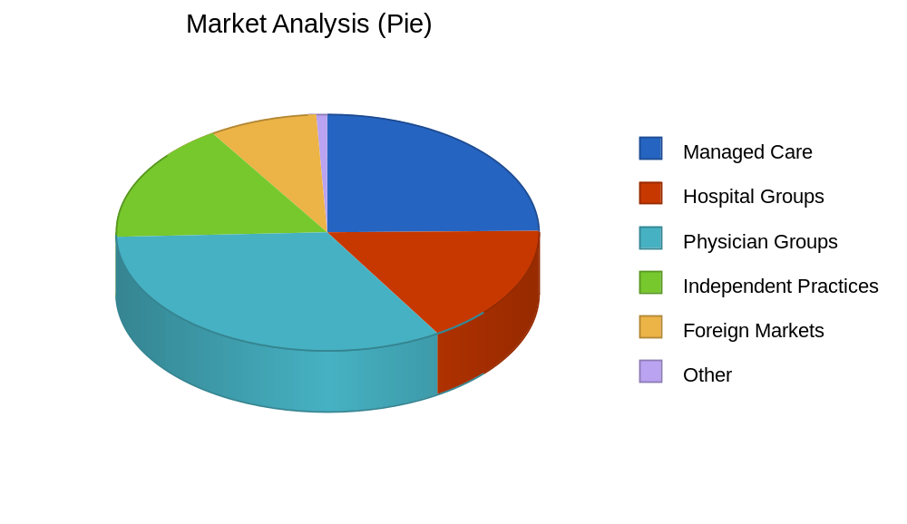

Table: Market Analysis

Market Analysis
 |  | Year 1 | Year 2 | Year 3 | Year 4 | Year 5
Potential Customers | Growth |  |  |  |  |  | CAGR
Managed Care | 25% | 300 | 375 | 469 | 586 | 733 | 25.02%
Hospital Groups | 10% | 200 | 220 | 242 | 266 | 293 | 10.02%
Physician Groups | 10% | 400 | 440 | 484 | 532 | 585 | 9.97%
Independent Practices | 0% | 200 | 200 | 200 | 200 | 200 | 0.00%
Foreign Markets | 50% | 100 | 150 | 225 | 338 | 507 | 50.06%
Other | 0% | 10 | 10 | 10 | 10 | 10 | 0.00%
Total | 17.77% | 1,210 | 1,395 | 1,630 | 1,932 | 2,328 | 17.77%

4.2 Industry Analysis
The health care industry in the United States has been dominated by managed care and hospital buying groups. Lowest total cost treatment has been the evolution of the pricing model. Medquip is ideally positioned to capitalize on this trend. There has been a rapid trend to endoscopic variceal ligation from the previous norm of sclerotherapy for the following reasons:
- Fewer post-op complications.
- Better control of bleeding.
- Lower risk of re-bleeding.
- Reduction of over-all treatment cost.
- Positioned ideally for managed care.
- Current research studies available.
The growth of banding has been as high as 30% per quarter according to IMI. The top 25 to 50 customers in each market category may account for as much as 70% of the potential business, making it easy to target customers with a multi-channel tiered strategy. The foreign markets may be penetrated initially with as few as four key distributors.

4.2.1 Competition and Buying Patterns
Large companies with established brand names and distribution patterns have a distinct advantage in the medical device arena. But new small companies are succeeding on a regular basis dependent on their technology and its over-all cost-of-treatment advantages. Product cost in and of itself is not paramount but education and training are. The product must deliver performance as promised in order to do a procedure more effectively with the fewest complications.
Time saving and effectiveness are the key economic parameters. Medquip will succeed based upon the capability of its products. They are already competitively priced...except they are more effective. After initial market resistance to any new product, Medquip's products can grow to dominate a market segment...in this case distinct surgical applications.
Variceal ligation is a huge and growing market. The market for the band dispenser is a currently existing one with accurate, up-to-date data from IMI. This clearly defined market represents one of the fastest growing segments in the medical device industry. The reason is that doctors are transitioning rapidly from the old and traditional sclerotherapy surgical protocol to banding procedures.
The entire endoscopic market is a $1 billion annual market. Nationally, upper GI endoscopy accounts for more than 1.2 million procedures per year according to MDI. The trend from endoscopic sclerotherapy (ES) to endoscopic variceal ligation (EVL) has been rapid.
In dollars the Endoscopy--Misc. Supplies category has been growing by 30% per quarter. The most recent qtr. ending June ‘97 was $18.8 million (IMI). The market segment exceeds $70 million in annual sales. This growth can be pegged almost exclusively to the market share gained by EVL at the expense of ES. Best estimates indicate that the percent of EVL procedures to total procedures is still in the 30% to 40% range. Thus, the potential market for EVL could be as high as $180 million.

4.2.2 Main Competitors
The most important competitor to be considered is Microvasive (Boston Scientific). Its strengths are its reputation, current market position, and its entrenched loyalty among physicians using its products. Its weakness is that it is not particularly innovative, normally depending on other companies to develop and perfect its technologies. This makes it vulnerable to a new, improved entry.
Eric Smith did significant design work for the company that perfected the Speedband for Microvasive. He is well aware of the performance gaps in the product.

4.2.3 Industry Participants
The major companies in the endoscopic device field directly competitive with Medquip proposed products are Microvasive (Boston Scientific), Bard, and Wilson-Cook. No manufacturer has a product competitive with the Visi-Gator although a company like Johnson and Johnson could be a likely joint venture partner or licensee.
Managed care providers such as Humana, Kaiser, Blue Cross, etc. are easily identified. Hospital groups are also easily identified as are physician groups.
However, buying methods are diverse, and there is significant overlap of decision making between these segments. That is why it is imperative that Medquip have an experienced CEO and an experienced Sales and Marketing Manager to effectively attack these channels.

4.2.4 Distribution Patterns
Distribution patterns in the health care industry are such that the large buying groups dictate what products are used for certain procedures throughout their sphere of influence. Thus, our products could be mandated or forced out for thousands of patients due to their health plan or hospital group. Others recommend several alternatives which require physician education and intervention, similar to pharmaceuticals.
Distributors are key for foreign markets.

5.0 Strategy and Implementation Summary
Medquip, Inc. will pursue specific, definable, market segments with a multi-tiered, multi-channel approach. We will leverage our technologies with a licensing agreement in one key area and a direct sales and distribution strategy in the other using established distributors.
We will look to foreign markets first with established distributors for initial revenue. Domestic revenue will follow. Large groups and plans will be targeted first.

5.1 Marketing Strategy
Marketing will follow from industry and trade and physician awareness campaigns to specific executions directed at specific customer segments. The top tier of 20 to 30 customers in each segment will be attacked first. Only a few sales hits in these top tiers will enable achievement of targeted forecasts. Medquip will achieve its initial sales goals from direct and distributed sales of the Visi-Band. This product is targeted first since it is an existing, well-defined market and 510k approval is anticipated. Worldwide sales through distributors will provide needed cash flow.

5.1.1 Promotion Strategy
Public relations, industry media, will help in over-all industry awareness plans. Feature articles and product reviews will help launch awareness. Direct mail to buying groups and ads in trade publications will help with buyer impressions. Finally, all will be integrated with physician materials and training video tapes once approval has been obtained to increase point-of-surgery usage.
Medquip has already worked closely with physicians to design its products. The importance of working with physicians is well known. As an outgrowth of our Physician Advisory Board, Medquip will actively recruit allied physicians with sponsored events and seminars. Every major market area will be targeted. An annual event will also be sponsored.

5.1.2 Pricing Strategy
Pricing for the Visi-Band is $250 per unit. Terms are 2% 10 days, net 30. All collections in this plan for cash flow purposes are based on an average 45 day collection span. Our 80% gross margin allows for factoring receivables if that should become viable or necessary.
A 30% discount will be offered to distributors. Quantity discounts are not included but remain possible in negotiations with major buying groups.
The Visi-Gator is priced in two components:
- The motorized unit at $1,000.
- The cutting/irrigation/suction component at $200 (disposable).
Note: These are suggested retail prices. They represent ten times our estimated cost of manufacture. However, the strategy is to license these products for a 10% royalty. Pricing would be negotiated with the licensee.

5.2 Sales Strategy
Medquip's sales strategy is to open foreign markets on a limited basis at the end of '98. To fully exploit them in '99 along with initial penetration of the US market with the Visi-Band (assuming 510k approval). Then to grow both markets in 2000 up to a 10% penetration.
Additionally, the strategy is to license the Visi-Gator to a major company such as J&J due to its increased regulatory requirements and initial marketing costs due to the fact that it is a new segment entry. The objective for the license is a $500,000 fee, $500,000 in advance royalties and a 10% royalty level per unit. Royalty projections are included in '99 and '00 sales forecasts.

5.2.1 Sales Forecast
This sales forecast includes small unit sales into the international market. The product is the Visi-Band. Unit sales are at $250 US. Product cost of direct sales is 20% while product cost through distributors is 50%.
It is important to note that $500k license fee and $500k advance royalties are the target figures for a license on the Visi-Gator. If these figures are not attainable or turn out to be a lesser number (but still acceptable to the Medquip board) then they should not be considered for cash flow purposes.
Investment money sought for Medquip will still be based on a sales forecast that does not include a successful license sale.

Table: Sales Forecast

Sales Forecast
 | Year 1 | Year 2 | Year 3
Sales
Visi-Band (direct) | $61,750 | $1,300,000 | $5,200,000
Visi-Band (distributor) | $136,500 | $3,600,000 | $16,250,000
Other | $0 | $0 | $0
Total Sales | $198,250 | $4,900,000 | $21,450,000
Direct Cost of Sales | Year 1 | Year 2 | Year 3
Visi-Band (direct) | $12,350 | $260,000 | $1,040,000
Visi-Band (distributor) | $50,505 | $1,332,000 | $6,012,500
Other | $0 | $0 | $0
Subtotal Direct Cost of Sales | $62,855 | $1,592,000 | $7,052,500

Chart: Sales Monthly
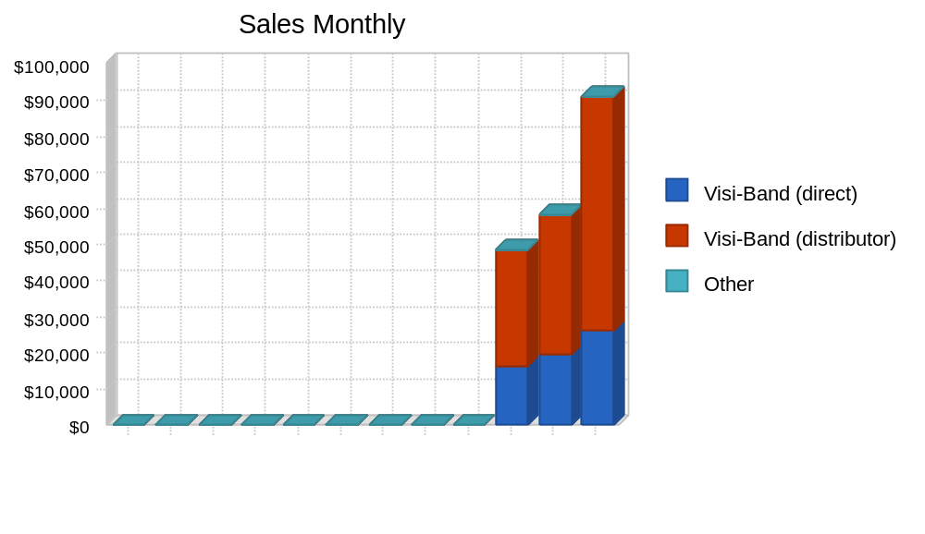

Chart: Sales by Year
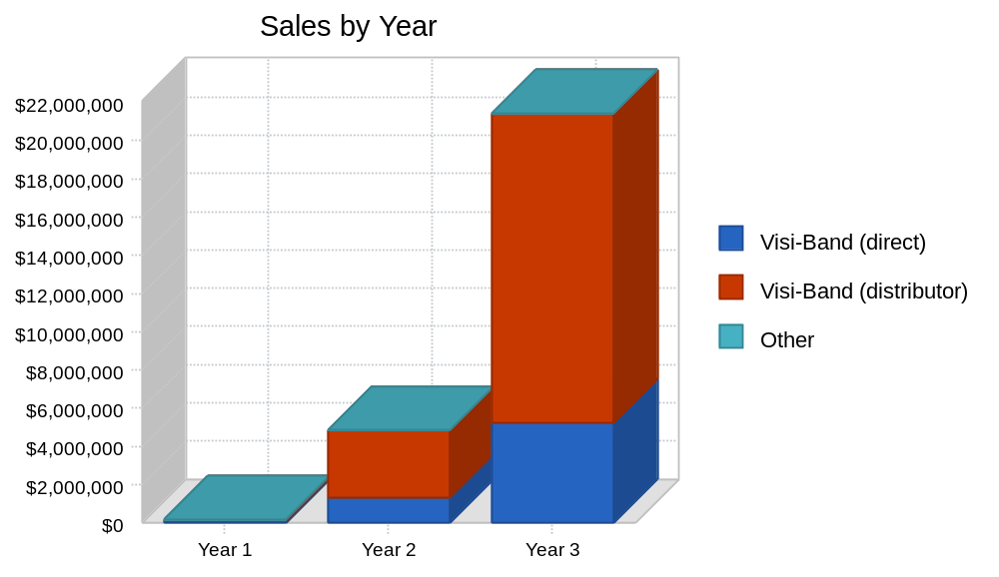

5.2.2 Sales Programs
Sales programs include direct wholesale sales to international distributors. Sales materials, video training tapes, and support materials will be produced. Physician materials will be included.
Direct sales will be by personal contact, direct mail, public relations, and media directed at key industry segments.
In addition electronic marketing will be deployed whenever it fits with the buying patterns of a key group.
A website and electronic commerce site will be utilized to cultivate direct sales to key industry groups.

5.3 Milestones
The following are the key milestones for the first year of operations.
- All patents will be applied for by the May 1st date. The total legal fees are expected to be less than the $50k allocated.
- Start-up capital was successfully raised.
- The business plan has been completed.
- The government of Puerto Rico has been presented on April 8, 1998.
- All other first year milestones are currently on target time wise and budget wise.

Table: Milestones

Milestones
Milestone | Start Date | End Date | Budget | Manager | Department
Patent Applications Complete | 1/1/1998 | 5/1/1998 | $50,000 | Smith | R&D
Start-up Investment | 1/1/1998 | 1/30/1998 | $0 | Jones | Finance
Business Plan | 1/7/1998 | 2/7/1998 | $3,000 | Jones | Finance
Private Placement | 1/1/1998 | 6/1/1998 | $0 | Jones | Finance
Puerto Rico Funding | 2/1/1998 | 6/1/1998 | $0 | Jones | Finance
Corporate Identity | 4/1/1998 | 4/30/1998 | $975 | Jones | Finance
CEO hire | 3/1/1998 | 6/1/1998 | $50,000 | Jones | G&A
Engineering Personnel | 2/1/1998 | 6/1/1998 | $0 | Smith | R&D
Puerto Rico Operation | 6/1/1998 | 12/31/1998 | $1,000,000 | Smith | R&D
Initial Sales | 6/1/1998 | 10/1/1998 | $0 | CEO | Marketing
Totals |  |  | $1,103,975

Chart: Milestones
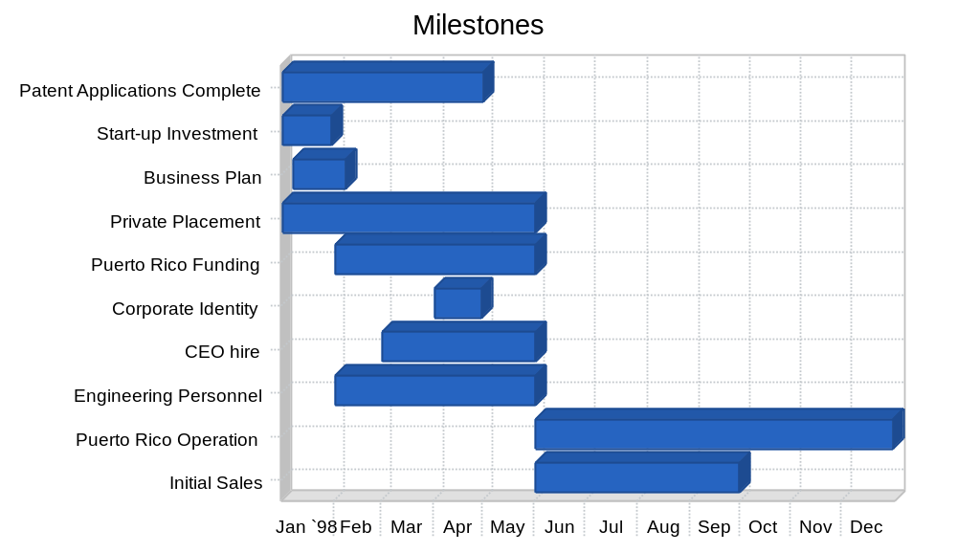

6.0 Management Summary
The founders of CMED, Corp. are Abubakar S. Abubakar and Ahmad sani K. Abubakar will serve the company as Vice-President of Research & Development. Ahmad will serve as Vice-President of Corporate Development. Their biographies follow in the Management Team section.
Several key people are actively being sought. These are summarized in Management Team Gaps.

6.1 Organizational Structure
CMED, Corp. will have a CEO to be recruited (see Management Team Gaps) who will have Abubakar S. Abubakar reporting to him as well as Ahmad Sani K and a V.P. of Sales and Marketing (see Management Team Gaps).
Abubakar will handle responsibility for R&D, design, compliance, and initial manufacturing and sourcing.
Ahmad will handle strategic growth plans, capitalization, and serve as CFO initially.
Reporting to Abubakar will be additional design engineers and compliance documentation personnel. Some of these tasks can also be handled by outside consultants in the early going. The ramp-up of essential personnel and tasks are included in the Personnel Plan that follows.

6.2 Management Team
Eric Smith (40)
BS, Mechanical Engineering, M.I.T., 1980
Eric Smith began his training in mechanical engineering at MIT and has a broad background in leading edge medical, semiconductor, biotechnology, and cleanroom product design and management. Creatively integrating technologies from diverse fields and transforming these elements into world class product solutions is his specialty. He has spent the past two years developing two medical devices, a full visibility ligating band dispenser and a revolutionary tissue dissolving lysis technology. Recent accomplishments include innovations for the Boston Scientific Speedband multiple ligating band dispenser. He was also responsible for the mechanism design of the Boston Scientific Corp. Alliance esophageal balloon inflation device through their supplier, ACT Medical Corp. Both devices have rapidly attained significantly greater than a 50% world market share for Boston Scientific Corp. Smith pioneered the application of high-energy particle beams to titanium hip and knee implants to increase their life by a factor of ten and for this work received an Industrial Research and Development IR100 award for one of the 100 best technology products. He initiated the development of a peritoneal dialysis system for Millipore Corporation, which incorporated ultra pure water and sterile connection technologies. Earlier research and development on the first Nitinol blood clot filter at Harvard Medical School was in cooperation with Dr. Morris Simon. Mr. Smith also was a founder of ABS, Inc., in 1995, a bio remediation products company currently manufacturing and cross licensing technology sold worldwide.
Ten United States Patents have been issued to Smith to date. Several more have also been granted internationally. A total of sixty-four subsequent United States patents granted to corporations including IBM, Medtronics, Northrop Grumman, Applied Materials, Eaton, Hitachi, and others cite these ten patents granted to Smith, a strong indication of the strategic significance of his diverse body of work. A number of biotechnology patent applications are currently being prosecuted in the United States and in several other countries. Patents issued to Smith include a medical X-ray system, clean room laminar airflow systems, chemical and thermal transfer processes, and robotic mechanisms for semiconductor and medical particle accelerators used worldwide by leading corporations such as Intel, IBM, Hitachi, Fujitsu, Motorola. A detailed list is below.
Mr. Smith has led new product developments for the past 17 years as Director of Engineering and Technology and various Research and Development positions. He led the systems design team for a $3 million production particle accelerator with a $50 million product development budget as Mechanical Systems Manager for Varian Associates, a large multinational technology corporation. He has managed an international staff of engineers and successfully transferred leading edge technology from Far East joint venture partners. His responsibilities have also included manufacturing management for a supplier of critical production equipment to IBM, Intel, and Eastman Kodak CD. Systems plagued by months of installation, rework, and errors performed flawlessly the first time and every time at Intel wafer fabrication cleanrooms after Smith re-designed the product and assumed full manufacturing responsibility.
An invited speaker at a worldwide technical conference in Kyoto, Japan, publications include a recent cover story for "Cleanrooms" magazine, and numerous technical articles related to high purity manufacturing, robotics, heat transfer, and mechanism designs.
United States Patent Numbers and Titles Currently Issued to Eric Smith as inventor:
5040484 Apparatus for retaining wafers [Semiconductor].
4997606 Methods and apparatus for fabricating a high purity thermally-conductive polymer.
4927438 Horizontal laminar air flow work station [Semiconductor and medical applications].
4899059 Disk scanning apparatus for batch ion implanters.
4836733 Wafer transfer system [Robot].
4832781 Methods and apparatus for thermal transfer with a semiconductor wafer in a vacuum.
4817556 Apparatus for retaining wafers.
4580058 Scanning treatment apparatus [Application: human hip and knee implants].
4531821 Item transporting [medical X-ray].
Timothy R. Jones (50)
BBA, Marketing, U. of Notre Dame, 1970
MBA, Finance, Executive Program, Loyola University, 1972
Mr. Jones has more than 27 years of business management experience. He is the founder of Plinth Capital in Ourtown, USA. He has successfully assisted early stage companies in capital formation, strategic planning, and business growth. His background includes management positions with two Fortune 500 companies, Lever Brothers Company, and the LCR Division of Squibb, Inc. Mr. Jones has previously been an executive in three start-up ventures and one turn-around.
His experience includes working with two investment banking firms, one that focused on privately held companies and the other on early stage publicly traded companies in development stage. Additionally, the management team of Medquip, Inc. includes a physician advisory board which is already being assembled. The Board of Directors is currently open.

6.3 Management Team Gaps
An experienced CEO is actively being sought. Ahmad Sani is presently conducting the search. The desired profile is for a CEO experienced in the medical device arena, ideally who was part of a previous start-up venture that grew to exceed a minimum of $20 million in sales and had a successful exit strategy.
The CEO will help to identify and bring in a VP of Sales and Marketing.
Abubakar S. Abubakar is actively searching for design engineers and consultants. Several have been identified and are available.

6.4 Personnel Plan
The Personnel Plan chronicles the growth of the organization to 31 employees in the first three years. The third year could require a few additional people besides those indicated especially if sales reach or exceed $20 million. Production assembly people are grouped together at approx. $15k per person. Payroll costs and benefits are pegged at 22% although they could be lower in Puerto Rico.

Table: Personnel

Personnel Plan
 | Year 1 | Year 2 | Year 3
Production Personnel
Production Manager | $20,000 | $60,000 | $64,000
Assembly Workers | $24,000 | $72,000 | $90,000
Subtotal | $44,000 | $132,000 | $154,000
Sales and Marketing Personnel
VP Sales & Marketing | $30,000 | $60,000 | $66,000
Sales Manager | $20,000 | $50,000 | $55,000
Field Sales Mgr. | $0 | $0 | $56,000
Marketing/Product Mgr. | $0 | $0 | $55,000
Sales Reps (3) | $0 | $0 | $144,000
Sales Administrator | $8,000 | $24,000 | $26,500
Subtotal | $58,000 | $134,000 | $402,500
General and Administrative Personnel
CEO | $56,000 | $96,000 | $110,000
VP Corp Development | $42,000 | $55,000 | $60,000
CFO | $0 | $84,000 | $90,000
Executive Assistant | $16,800 | $30,000 | $32,000
Executive Secretary | $0 | $0 | $24,000
Controller | $25,200 | $45,000 | $48,000
Administrative Staff (4) | $0 | $0 | $88,000
Subtotal | $140,000 | $310,000 | $452,000
Other Personnel
VP Research & Dev. | $42,000 | $55,000 | $60,000
Design Engineer | $42,000 | $84,000 | $88,000
Compliance Specialist | $24,000 | $47,000 | $50,000
Junior Engineer | $16,000 | $40,000 | $45,000
Research Engineers (3) | $0 | $0 | $140,000
Subtotal | $124,000 | $226,000 | $383,000
Total People | 0 | 0 | 0
Total Payroll | $366,000 | $802,000 | $1,391,500

7.0 Financial Plan
The value of the patents and the size of their potential markets enables several back-up plans of action if this plan doesn't work as indicated. Venture funds are available early on and historically investments of $3 to $5 million are common for similar companies.
Even after successfully completing the start and seed stage as indicated, second round venture or mezzanine funding is potentially available in the $5 million range. We have planned for additional capital input in years two and three as a safety net for cash flow/cash balance.
However, cash flow achievement within the parameters of the indicated plan plus further funding on the senior debt side will lead to the best value for shareholders. Then, strategy can dictate the best valuation for ramp-up and roll-out.

7.1 Important Assumptions
The following are the key financial assumptions for this plan. However, it's important to note that several of the assumptions could be considerably less than those indicated if the business is located in Puerto Rico. The personnel burden could go from 22% to 12%. The short term interest rate could go from 10% to 5% or less. The tax rate could go from 25% to less than 10%. So, all of the bottom line projections in this plan could improve appreciably.
However, the plan is still based on the following assumptions as if it were a U.S. based Georgia operation.

Table: General Assumptions

General Assumptions
 | Year 1 | Year 2 | Year 3
Plan Month | 1 | 2 | 3
Current Interest Rate | 10.00% | 10.00% | 10.00%
Long-term Interest Rate | 10.00% | 10.00% | 10.00%
Tax Rate | 0.00% | 30.00% | 30.00%
Other | 0 | 0 | 0

7.2 Key Financial Indicators
All of our benchmarks being attained will allow expansion strategies of merger, acquisition, roll-up or IPO. The following chart illustrates our planned performance in the most critical profit variables.

Chart: Benchmarks
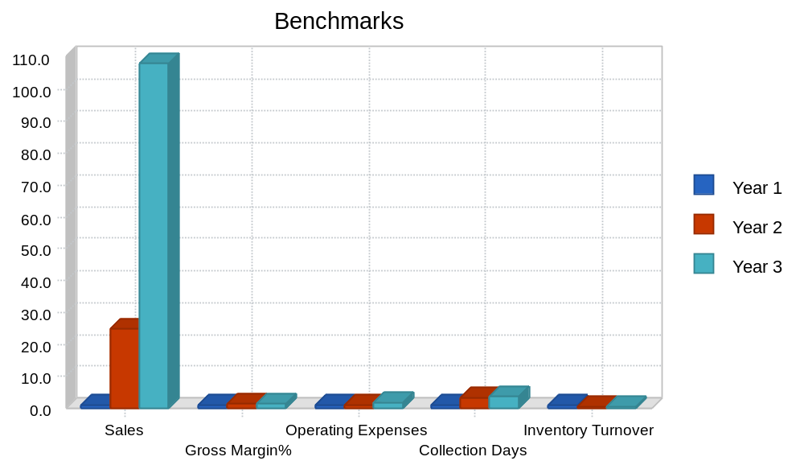

7.3 Break-even Analysis
Medquip, Inc. has calculated a break-even maintenance point for sales once full management staffing and facility costs are reached. Included are payroll and rent considerations.
The break-even target can sustain Medquip, Inc. in operation in late '98 and throughout '99 even if expansion and capitalization plans are late in materializing. It is anticipated that direct sales can produce these numbers and more in Europe, Middle Eastern, and African markets since those markets are not as dominated by managed care, there is more direct purchasing. A distributor has been identified for those markets as well as a distributor for Latin and South America, and a distributor for Japan. No Japanese sales are included, however, since regulatory barriers are more pronounced there.
The break-even analysis is restricted to this late '98 and early '99 time frame since the early ramp-up phase in business development is characteristic of most cash-flow shortages that represent exposure to early stage investors.

Table: Break-even Analysis

Break-even Analysis
Monthly Revenue Break-even | $198,088
Assumptions:
Average Percent Variable Cost | 32%
Estimated Monthly Fixed Cost | $135,284

Chart: Break-even Analysis
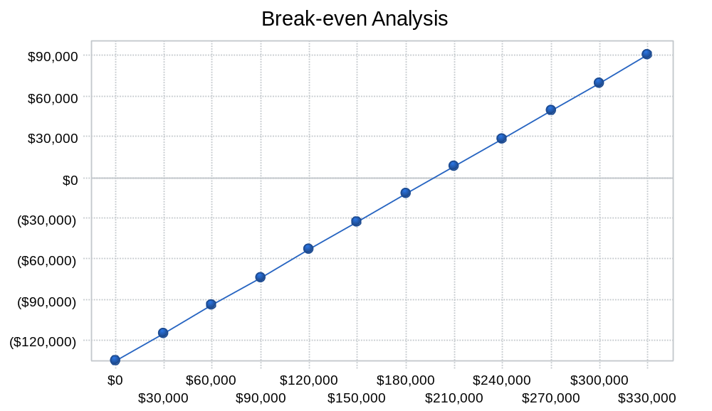

7.4 Projected Profit and Loss
The profit in each of the first two years of operation is expected to be minimal. However that includes $1 million in revenue in the first year from the sale of a license. If that does not occur, then over $800k will be burned in year one. That must come from investment infusion. The third year profit reflects the performance of a mature company. Over-all gross margins are excellent.

Chart: Gross Margin Monthly
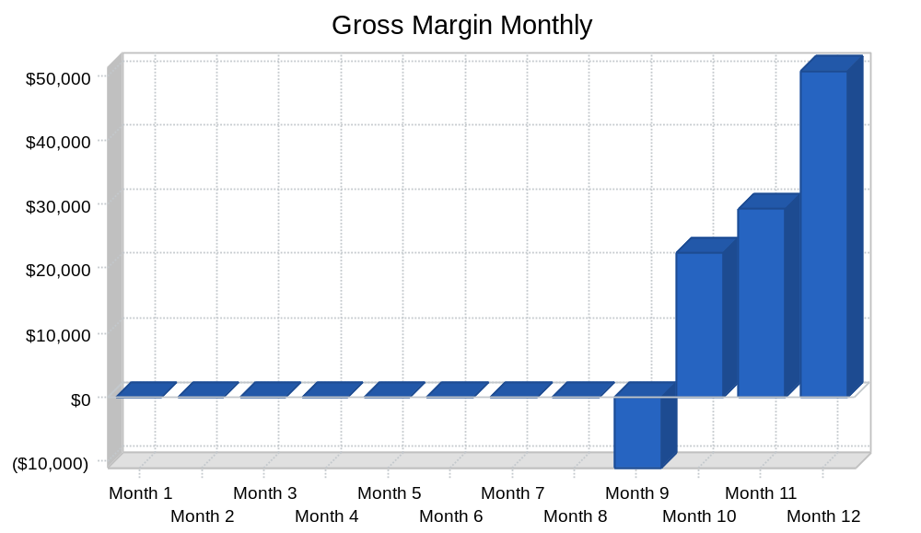

Chart: Gross Margin Yearly
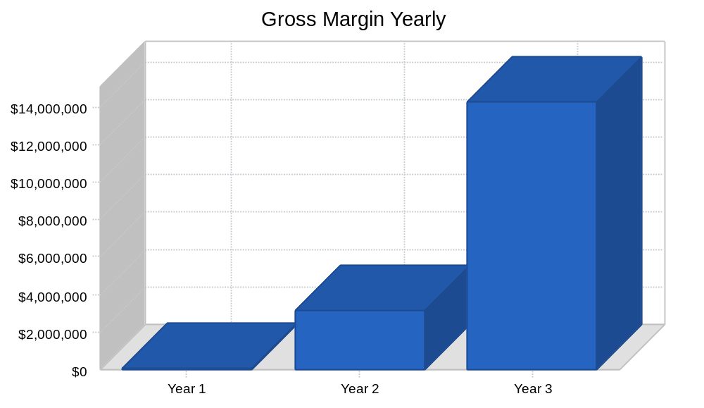

Table: Profit and Loss

Pro Forma Profit and Loss
 | Year 1 | Year 2 | Year 3
Sales | $198,250 | $4,900,000 | $21,450,000
Direct Cost of Sales | $62,855 | $1,592,000 | $7,052,500
Production Payroll | $44,000 | $132,000 | $154,000
Other Costs of Sales | $0 | $0 | $0
Total Cost of Sales | $106,855 | $1,724,000 | $7,206,500
Gross Margin | $91,395 | $3,176,000 | $14,243,500
Gross Margin % | 46.10% | 64.82% | 66.40%
Operating Expenses
Sales and Marketing Expenses
Sales and Marketing Payroll | $58,000 | $134,000 | $402,500
Advertising/Promotion | $16,000 | $150,000 | $700,000
Travel | $13,000 | $66,000 | $88,000
Miscellaneous | $6,000 | $15,000 | $24,000
Total Sales and Marketing Expenses | $93,000 | $365,000 | $1,214,500
Sales and Marketing % | 46.91% | 7.45% | 5.66%
General and Administrative Expenses
General and Administrative Payroll | $140,000 | $310,000 | $452,000
Marketing/Promotion | $0 | $0 | $0
Depreciation | $0 | $0 | $0
Leased Equipment | $1,000,000 | $0 | $500,000
Rent | $58,950 | $75,000 | $95,000
Utilities | $5,000 | $6,000 | $7,000
Insurance | $39,000 | $45,000 | $51,000
Legal Expenses | $93,563 | $36,000 | $36,000
Payroll Taxes | $54,900 | $120,300 | $208,725
Other General and Administrative Expenses | $0 | $0 | $0
Total General and Administrative Expenses | $1,391,413 | $592,300 | $1,349,725
General and Administrative % | 701.85% | 12.09% | 6.29%
Other Expenses:
Other Payroll | $124,000 | $226,000 | $383,000
Consultants | $0 | $0 | $0
Contract/Consultants | $15,000 | $30,000 | $60,000
Total Other Expenses | $139,000 | $256,000 | $443,000
Other % | 70.11% | 5.22% | 2.07%
Total Operating Expenses | $1,623,413 | $1,213,300 | $3,007,225
Profit Before Interest and Taxes | ($1,532,018) | $1,962,700 | $11,236,275
EBITDA | ($1,532,018) | $1,962,700 | $11,236,275
Interest Expense | $5,000 | $55,000 | $51,250
Taxes Incurred | $0 | $572,310 | $3,355,508
Net Profit | ($1,537,018) | $1,335,390 | $7,829,518
Net Profit/Sales | -775.29% | 27.25% | 36.50%

Chart: Profit Monthly
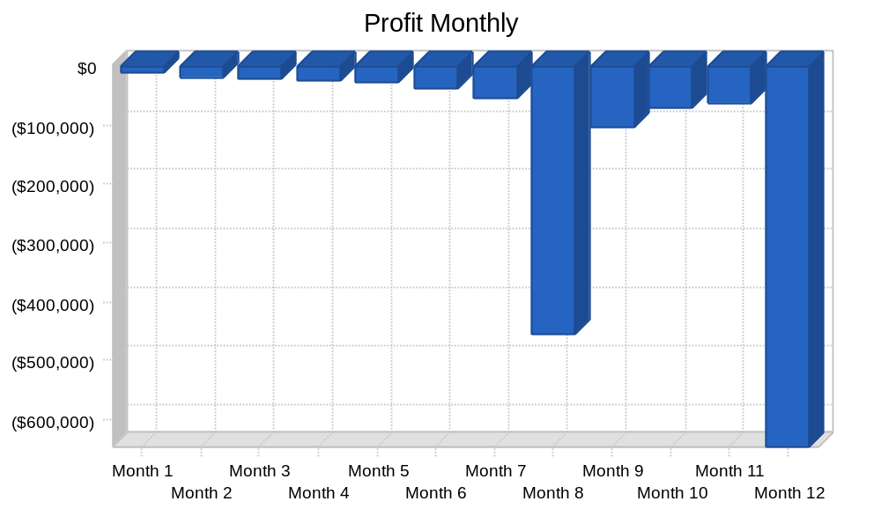

Chart: Profit Yearly
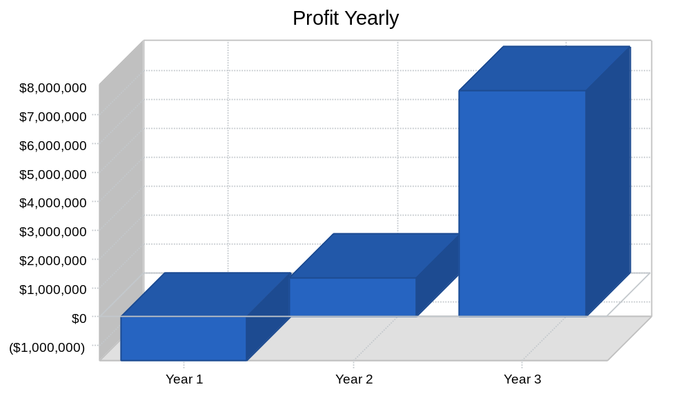

7.5 Projected Cash Flow
We began the year with $128,000 in cash from initial sales of shares to investors. This provided our start-up capital. The private placement to 13 or fewer investors is expected to bring in another $450,000 in May and $400,000 in June. We are targeting an additional equity investment from Puerto Rico and long term loans.
Thus, our cash flow will be sufficient in year one even if we can't conclude a licensing agreement.
Second round financing will include venture, mezzanine, or IPO options. If sales and profits hit targets then further investment needs will be limited to higher value options to roll-up a national level and world-wide company.

Table: Cash Flow

Pro Forma Cash Flow
 | Year 1 | Year 2 | Year 3
Cash Received
Cash from Operations
Cash Sales | $69,388 | $1,715,000 | $7,507,500
Cash from Receivables | $32,955 | $910,432 | $5,936,098
Subtotal Cash from Operations | $102,343 | $2,625,432 | $13,443,598
Additional Cash Received
Sales Tax, VAT, HST/GST Received | $0 | $0 | $0
New Current Borrowing | $0 | $0 | $125,000
New Other Liabilities (interest-free) | $600,000 | $0 | $0
New Long-term Liabilities | $600,000 | $0 | $0
Sales of Other Current Assets | $0 | $0 | $0
Sales of Long-term Assets | $0 | $0 | $0
New Investment Received | $850,000 | $1,869,000 | $0
Subtotal Cash Received | $2,152,343 | $4,494,432 | $13,568,598
Expenditures | Year 1 | Year 2 | Year 3
Expenditures from Operations
Cash Spending | $366,000 | $802,000 | $1,391,500
Bill Payments | $734,012 | $3,853,163 | $12,379,035
Subtotal Spent on Operations | $1,100,012 | $4,655,163 | $13,770,535
Additional Cash Spent
Sales Tax, VAT, HST/GST Paid Out | $0 | $0 | $0
Principal Repayment of Current Borrowing | $0 | $0 | $0
Other Liabilities Principal Repayment | $0 | $600,000 | $0
Long-term Liabilities Principal Repayment | $0 | $100,000 | $100,000
Purchase Other Current Assets | $0 | $0 | $0
Purchase Long-term Assets | $0 | $0 | $0
Dividends | $0 | $0 | $0
Subtotal Cash Spent | $1,100,012 | $5,355,163 | $13,870,535
Net Cash Flow | $1,052,331 | ($860,731) | ($301,937)
Cash Balance | $1,180,331 | $319,600 | $17,663

Chart: Cash
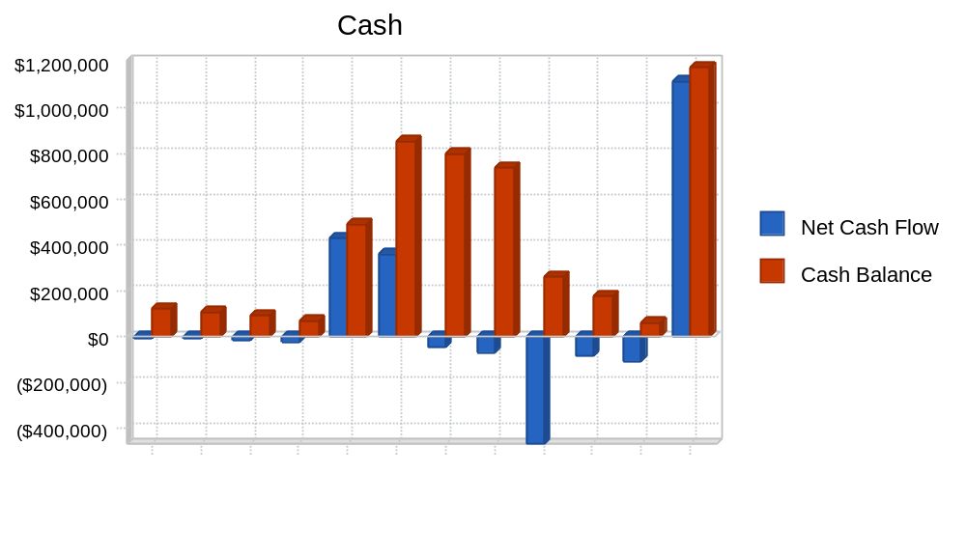

7.6 Projected Balance Sheet
The highlights of the balance sheets are a solid cash position and net worth at the end of year three.

Table: Balance Sheet

Pro Forma Balance Sheet
 | Year 1 | Year 2 | Year 3
Assets
Current Assets
Cash | $1,180,331 | $319,600 | $17,663
Accounts Receivable | $95,908 | $2,370,475 | $10,376,877
Inventory | $29,250 | $740,848 | $1,688,348
Other Current Assets | $0 | $0 | $0
Total Current Assets | $1,305,488 | $3,430,923 | $12,082,888
Long-term Assets
Long-term Assets | $0 | $0 | $0
Accumulated Depreciation | $0 | $0 | $0
Total Long-term Assets | $0 | $0 | $0
Total Assets | $1,305,488 | $3,430,923 | $12,082,888
Liabilities and Capital | Year 1 | Year 2 | Year 3
Current Liabilities
Accounts Payable | $664,506 | $285,551 | $1,082,999
Current Borrowing | $0 | $0 | $125,000
Other Current Liabilities | $600,000 | $0 | $0
Subtotal Current Liabilities | $1,264,506 | $285,551 | $1,207,999
Long-term Liabilities | $600,000 | $500,000 | $400,000
Total Liabilities | $1,864,506 | $785,551 | $1,607,999
Paid-in Capital | $1,108,000 | $2,977,000 | $2,977,000
Retained Earnings | ($130,000) | ($1,667,018) | ($331,628)
Earnings | ($1,537,018) | $1,335,390 | $7,829,518
Total Capital | ($559,018) | $2,645,372 | $10,474,890
Total Liabilities and Capital | $1,305,488 | $3,430,923 | $12,082,888
Net Worth | ($559,018) | $2,645,372 | $10,474,890

7.7 Business Ratios
By year three the return on equity should be very attractive to early investors. All ratios are in good shape for traditional borrowing to fund further growth. Industry profile ratios based on the Standard Industrial Classification (SIC) code 3841, Surgical and Medical Instruments, are shown for comparison.

Table: Ratios
Ratio Analysis
 | Year 1 | Year 2 | Year 3 | Industry Profile
Sales Growth | n.a. | 2371.63% | 337.76% | 4.20%
Percent of Total Assets
Accounts Receivable | 7.35% | 69.09% | 85.88% | 25.30%
Inventory | 2.24% | 21.59% | 13.97% | 14.90%
Other Current Assets | 0.00% | 0.00% | 0.00% | 42.70%
Total Current Assets | 100.00% | 100.00% | 100.00% | 82.90%
Long-term Assets | 0.00% | 0.00% | 0.00% | 17.10%
Total Assets | 100.00% | 100.00% | 100.00% | 100.00%
Current Liabilities | 96.86% | 8.32% | 10.00% | 39.60%
Long-term Liabilities | 45.96% | 14.57% | 3.31% | 18.10%
Total Liabilities | 142.82% | 22.90% | 13.31% | 57.70%
Net Worth | -42.82% | 77.10% | 86.69% | 42.30%
Percent of Sales
Sales | 100.00% | 100.00% | 100.00% | 100.00%
Gross Margin | 46.10% | 64.82% | 66.40% | 53.30%
Selling, General & Administrative Expenses | 821.39% | 37.56% | 29.90% | 34.40%
Advertising Expenses | 8.07% | 3.06% | 3.26% | 1.50%
Profit Before Interest and Taxes | -772.77% | 40.06% | 52.38% | 5.10%
Main Ratios
Current | 1.03 | 12.02 | 10.00 | 2.00
Quick | 1.01 | 9.42 | 8.60 | 1.33
Total Debt to Total Assets | 142.82% | 22.90% | 13.31% | 57.70%
Pre-tax Return on Net Worth | 274.95% | 72.11% | 106.78% | 5.80%
Pre-tax Return on Assets | -117.74% | 55.60% | 92.57% | 13.80%
Additional Ratios | Year 1 | Year 2 | Year 3
Net Profit Margin | -775.29% | 27.25% | 36.50% | n.a
Return on Equity | 0.00% | 50.48% | 74.75% | n.a
Activity Ratios
Accounts Receivable Turnover | 1.34 | 1.34 | 1.34 | n.a
Collection Days | 46 | 141 | 167 | n.a
Inventory Turnover | 12.00 | 4.13 | 5.81 | n.a
Accounts Payable Turnover | 2.10 | 12.17 | 12.17 | n.a
Payment Days | 27 | 50 | 19 | n.a
Total Asset Turnover | 0.15 | 1.43 | 1.78 | n.a
Debt Ratios
Debt to Net Worth | 0.00 | 0.30 | 0.15 | n.a
Current Liab. to Liab. | 0.68 | 0.36 | 0.75 | n.a
Liquidity Ratios
Net Working Capital | $40,982 | $3,145,372 | $10,874,890 | n.a
Interest Coverage | -306.40 | 35.69 | 219.24 | n.a
Additional Ratios
Assets to Sales | 6.59 | 0.70 | 0.56 | n.a
Current Debt/Total Assets | 97% | 8% | 10% | n.a
Acid Test | 0.93 | 1.12 | 0.01 | n.a
Sales/Net Worth | 0.00 | 1.85 | 2.05 | n.a
Dividend Payout | 0.00 | 0.00 | 0.00 | n.a

Table: Sales Forecast

Sales Forecast
 |  | Month 1 | Month 2 | Month 3 | Month 4 | Month 5 | Month 6 | Month 7 | Month 8 | Month 9 | Month 10 | Month 11 | Month 12
Sales
Visi-Band (direct) | 0% | $0 | $0 | $0 | $0 | $0 | $0 | $0 | $0 | $0 | $16,250 | $19,500 | $26,000
Visi-Band (distributor) | 0% | $0 | $0 | $0 | $0 | $0 | $0 | $0 | $0 | $0 | $32,500 | $39,000 | $65,000
Other | 0% | $0 | $0 | $0 | $0 | $0 | $0 | $0 | $0 | $0 | $0 | $0 | $0
Total Sales |  | $0 | $0 | $0 | $0 | $0 | $0 | $0 | $0 | $0 | $48,750 | $58,500 | $91,000
Direct Cost of Sales |  | Month 1 | Month 2 | Month 3 | Month 4 | Month 5 | Month 6 | Month 7 | Month 8 | Month 9 | Month 10 | Month 11 | Month 12
Visi-Band (direct) |  | $0 | $0 | $0 | $0 | $0 | $0 | $0 | $0 | $0 | $3,250 | $3,900 | $5,200
Visi-Band (distributor) |  | $0 | $0 | $0 | $0 | $0 | $0 | $0 | $0 | $0 | $12,025 | $14,430 | $24,050
Other |  | $0 | $0 | $0 | $0 | $0 | $0 | $0 | $0 | $0 | $0 | $0 | $0
Subtotal Direct Cost of Sales |  | $0 | $0 | $0 | $0 | $0 | $0 | $0 | $0 | $0 | $15,275 | $18,330 | $29,250

Table: Personnel

Personnel Plan
 |  | Month 1 | Month 2 | Month 3 | Month 4 | Month 5 | Month 6 | Month 7 | Month 8 | Month 9 | Month 10 | Month 11 | Month 12
Production Personnel
Production Manager |  | $0 | $0 | $0 | $0 | $0 | $0 | $0 | $0 | $5,000 | $5,000 | $5,000 | $5,000
Assembly Workers |  | $0 | $0 | $0 | $0 | $0 | $0 | $0 | $0 | $6,000 | $6,000 | $6,000 | $6,000
Subtotal |  | $0 | $0 | $0 | $0 | $0 | $0 | $0 | $0 | $11,000 | $11,000 | $11,000 | $11,000
Sales and Marketing Personnel
VP Sales & Marketing |  | $0 | $0 | $0 | $0 | $0 | $0 | $0 | $0 | $7,500 | $7,500 | $7,500 | $7,500
Sales Manager |  | $0 | $0 | $0 | $0 | $0 | $0 | $0 | $0 | $5,000 | $5,000 | $5,000 | $5,000
Field Sales Mgr. |  | $0 | $0 | $0 | $0 | $0 | $0 | $0 | $0 | $0 | $0 | $0 | $0
Marketing/Product Mgr. |  | $0 | $0 | $0 | $0 | $0 | $0 | $0 | $0 | $0 | $0 | $0 | $0
Sales Reps (3) |  | $0 | $0 | $0 | $0 | $0 | $0 | $0 | $0 | $0 | $0 | $0 | $0
Sales Administrator |  | $0 | $0 | $0 | $0 | $0 | $0 | $0 | $0 | $2,000 | $2,000 | $2,000 | $2,000
Subtotal |  | $0 | $0 | $0 | $0 | $0 | $0 | $0 | $0 | $14,500 | $14,500 | $14,500 | $14,500
General and Administrative Personnel
CEO |  | $0 | $0 | $0 | $0 | $0 | $8,000 | $8,000 | $8,000 | $8,000 | $8,000 | $8,000 | $8,000
VP Corp Development |  | $3,500 | $3,500 | $3,500 | $3,500 | $3,500 | $3,500 | $3,500 | $3,500 | $3,500 | $3,500 | $3,500 | $3,500
CFO |  | $0 | $0 | $0 | $0 | $0 | $0 | $0 | $0 | $0 | $0 | $0 | $0
Executive Assistant |  | $0 | $0 | $0 | $0 | $0 | $2,400 | $2,400 | $2,400 | $2,400 | $2,400 | $2,400 | $2,400
Executive Secretary |  | $0 | $0 | $0 | $0 | $0 | $0 | $0 | $0 | $0 | $0 | $0 | $0
Controller |  | $0 | $0 | $0 | $0 | $0 | $3,600 | $3,600 | $3,600 | $3,600 | $3,600 | $3,600 | $3,600
Administrative Staff (4) |  | $0 | $0 | $0 | $0 | $0 | $0 | $0 | $0 | $0 | $0 | $0 | $0
Subtotal |  | $3,500 | $3,500 | $3,500 | $3,500 | $3,500 | $17,500 | $17,500 | $17,500 | $17,500 | $17,500 | $17,500 | $17,500
Other Personnel
VP Research & Dev. |  | $3,500 | $3,500 | $3,500 | $3,500 | $3,500 | $3,500 | $3,500 | $3,500 | $3,500 | $3,500 | $3,500 | $3,500
Design Engineer |  | $0 | $0 | $0 | $0 | $0 | $0 | $7,000 | $7,000 | $7,000 | $7,000 | $7,000 | $7,000
Compliance Specialist |  | $0 | $0 | $0 | $0 | $0 | $0 | $4,000 | $4,000 | $4,000 | $4,000 | $4,000 | $4,000
Junior Engineer |  | $0 | $0 | $0 | $0 | $0 | $0 | $0 | $0 | $4,000 | $4,000 | $4,000 | $4,000
Research Engineers (3) |  | $0 | $0 | $0 | $0 | $0 | $0 | $0 | $0 | $0 | $0 | $0 | $0
Subtotal |  | $3,500 | $3,500 | $3,500 | $3,500 | $3,500 | $3,500 | $14,500 | $14,500 | $18,500 | $18,500 | $18,500 | $18,500
Total People |  | 0 | 0 | 0 | 0 | 0 | 0 | 0 | 0 | 0 | 0 | 0 | 0
Total Payroll |  | $7,000 | $7,000 | $7,000 | $7,000 | $7,000 | $21,000 | $32,000 | $32,000 | $61,500 | $61,500 | $61,500 | $61,500

Table: Profit and Loss

Pro Forma Profit and Loss
 |  | Month 1 | Month 2 | Month 3 | Month 4 | Month 5 | Month 6 | Month 7 | Month 8 | Month 9 | Month 10 | Month 11 | Month 12
Sales |  | $0 | $0 | $0 | $0 | $0 | $0 | $0 | $0 | $0 | $48,750 | $58,500 | $91,000
Direct Cost of Sales |  | $0 | $0 | $0 | $0 | $0 | $0 | $0 | $0 | $0 | $15,275 | $18,330 | $29,250
Production Payroll |  | $0 | $0 | $0 | $0 | $0 | $0 | $0 | $0 | $11,000 | $11,000 | $11,000 | $11,000
Other Costs of Sales |  | $0 | $0 | $0 | $0 | $0 | $0 | $0 | $0 | $0 | $0 | $0 | $0
Total Cost of Sales |  | $0 | $0 | $0 | $0 | $0 | $0 | $0 | $0 | $11,000 | $26,275 | $29,330 | $40,250
Gross Margin |  | $0 | $0 | $0 | $0 | $0 | $0 | $0 | $0 | ($11,000) | $22,475 | $29,170 | $50,750
Gross Margin % |  | 0.00% | 0.00% | 0.00% | 0.00% | 0.00% | 0.00% | 0.00% | 0.00% | 0.00% | 46.10% | 49.86% | 55.77%
Operating Expenses
Sales and Marketing Expenses
Sales and Marketing Payroll |  | $0 | $0 | $0 | $0 | $0 | $0 | $0 | $0 | $14,500 | $14,500 | $14,500 | $14,500
Advertising/Promotion |  | $0 | $0 | $0 | $0 | $0 | $0 | $0 | $0 | $4,000 | $4,000 | $4,000 | $4,000
Travel |  | $0 | $0 | $0 | $0 | $5,000 | $0 | $0 | $0 | $2,000 | $2,000 | $2,000 | $2,000
Miscellaneous |  | $0 | $0 | $0 | $0 | $0 | $0 | $0 | $0 | $1,500 | $1,500 | $1,500 | $1,500
Total Sales and Marketing Expenses |  | $0 | $0 | $0 | $0 | $5,000 | $0 | $0 | $0 | $22,000 | $22,000 | $22,000 | $22,000
Sales and Marketing % |  | 0.00% | 0.00% | 0.00% | 0.00% | 0.00% | 0.00% | 0.00% | 0.00% | 0.00% | 45.13% | 37.61% | 24.18%
General and Administrative Expenses
General and Administrative Payroll |  | $3,500 | $3,500 | $3,500 | $3,500 | $3,500 | $17,500 | $17,500 | $17,500 | $17,500 | $17,500 | $17,500 | $17,500
Marketing/Promotion |  | $0 | $0 | $0 | $0 | $0 | $0 | $0 | $0 | $0 | $0 | $0 | $0
Depreciation |  | $0 | $0 | $0 | $0 | $0 | $0 | $0 | $0 | $0 | $0 | $0 | $0
Leased Equipment |  | $0 | $0 | $0 | $0 | $0 | $0 | $0 | $400,000 | $0 | $0 | $0 | $600,000
Rent |  | $2,325 | $2,325 | $2,325 | $2,325 | $2,325 | $2,325 | $7,500 | $7,500 | $7,500 | $7,500 | $7,500 | $7,500
Utilities |  | $0 | $0 | $0 | $250 | $250 | $250 | $250 | $800 | $800 | $800 | $800 | $800
Insurance |  | $0 | $0 | $0 | $3,000 | $3,000 | $3,000 | $5,000 | $5,000 | $5,000 | $5,000 | $5,000 | $5,000
Legal Expenses | 0% | $1,050 | $9,890 | $8,123 | $10,000 | $10,000 | $8,000 | $4,800 | $4,800 | $9,225 | $9,225 | $9,225 | $9,225
Payroll Taxes | 15% | $1,050 | $1,050 | $1,050 | $1,050 | $1,050 | $3,150 | $4,800 | $4,800 | $9,225 | $9,225 | $9,225 | $9,225
Other General and Administrative Expenses |  | $0 | $0 | $0 | $0 | $0 | $0 | $0 | $0 | $0 | $0 | $0 | $0
Total General and Administrative Expenses |  | $7,925 | $16,765 | $14,998 | $20,125 | $20,125 | $34,225 | $39,850 | $440,400 | $49,250 | $49,250 | $49,250 | $649,250
General and Administrative % |  | 0.00% | 0.00% | 0.00% | 0.00% | 0.00% | 0.00% | 0.00% | 0.00% | 0.00% | 101.03% | 84.19% | 713.46%
Other Expenses:
Other Payroll |  | $3,500 | $3,500 | $3,500 | $3,500 | $3,500 | $3,500 | $14,500 | $14,500 | $18,500 | $18,500 | $18,500 | $18,500
Consultants |  | $0 | $0 | $0 | $0 | $0 | $0 | $0 | $0 | $0 | $0 | $0 | $0
Contract/Consultants |  | $0 | $0 | $3,000 | $0 | $0 | $0 | $0 | $0 | $3,000 | $3,000 | $3,000 | $3,000
Total Other Expenses |  | $3,500 | $3,500 | $6,500 | $3,500 | $3,500 | $3,500 | $14,500 | $14,500 | $21,500 | $21,500 | $21,500 | $21,500
Other % |  | 0.00% | 0.00% | 0.00% | 0.00% | 0.00% | 0.00% | 0.00% | 0.00% | 0.00% | 44.10% | 36.75% | 23.63%
Total Operating Expenses |  | $11,425 | $20,265 | $21,498 | $23,625 | $28,625 | $37,725 | $54,350 | $454,900 | $92,750 | $92,750 | $92,750 | $692,750
Profit Before Interest and Taxes |  | ($11,425) | ($20,265) | ($21,498) | ($23,625) | ($28,625) | ($37,725) | ($54,350) | ($454,900) | ($103,750) | ($70,275) | ($63,580) | ($642,000)
EBITDA |  | ($11,425) | ($20,265) | ($21,498) | ($23,625) | ($28,625) | ($37,725) | ($54,350) | ($454,900) | ($103,750) | ($70,275) | ($63,580) | ($642,000)
Interest Expense |  | $0 | $0 | $0 | $0 | $0 | $0 | $0 | $0 | $0 | $0 | $0 | $5,000
Taxes Incurred |  | $0 | $0 | $0 | $0 | $0 | $0 | $0 | $0 | $0 | $0 | $0 | $0
Net Profit |  | ($11,425) | ($20,265) | ($21,498) | ($23,625) | ($28,625) | ($37,725) | ($54,350) | ($454,900) | ($103,750) | ($70,275) | ($63,580) | ($647,000)
Net Profit/Sales |  | 0.00% | 0.00% | 0.00% | 0.00% | 0.00% | 0.00% | 0.00% | 0.00% | 0.00% | -144.15% | -108.68% | -710.99%

Table: Cash Flow

Pro Forma Cash Flow
 |  | Month 1 | Month 2 | Month 3 | Month 4 | Month 5 | Month 6 | Month 7 | Month 8 | Month 9 | Month 10 | Month 11 | Month 12
Cash Received
Cash from Operations
Cash Sales |  | $0 | $0 | $0 | $0 | $0 | $0 | $0 | $0 | $0 | $17,063 | $20,475 | $31,850
Cash from Receivables |  | $0 | $0 | $0 | $0 | $0 | $0 | $0 | $0 | $0 | $0 | $1,056 | $31,899
Subtotal Cash from Operations |  | $0 | $0 | $0 | $0 | $0 | $0 | $0 | $0 | $0 | $17,063 | $21,531 | $63,749
Additional Cash Received
Sales Tax, VAT, HST/GST Received | 0.00% | $0 | $0 | $0 | $0 | $0 | $0 | $0 | $0 | $0 | $0 | $0 | $0
New Current Borrowing |  | $0 | $0 | $0 | $0 | $0 | $0 | $0 | $0 | $0 | $0 | $0 | $0
New Other Liabilities (interest-free) |  | $0 | $0 | $0 | $0 | $0 | $0 | $0 | $0 | $0 | $0 | $0 | $600,000
New Long-term Liabilities |  | $0 | $0 | $0 | $0 | $0 | $0 | $0 | $0 | $0 | $0 | $0 | $600,000
Sales of Other Current Assets |  | $0 | $0 | $0 | $0 | $0 | $0 | $0 | $0 | $0 | $0 | $0 | $0
Sales of Long-term Assets |  | $0 | $0 | $0 | $0 | $0 | $0 | $0 | $0 | $0 | $0 | $0 | $0
New Investment Received |  | $0 | $0 | $0 | $0 | $450,000 | $400,000 | $0 | $0 | $0 | $0 | $0 | $0
Subtotal Cash Received |  | $0 | $0 | $0 | $0 | $450,000 | $400,000 | $0 | $0 | $0 | $17,063 | $21,531 | $1,263,749
Expenditures |  | Month 1 | Month 2 | Month 3 | Month 4 | Month 5 | Month 6 | Month 7 | Month 8 | Month 9 | Month 10 | Month 11 | Month 12
Expenditures from Operations
Cash Spending |  | $7,000 | $7,000 | $7,000 | $7,000 | $7,000 | $21,000 | $32,000 | $32,000 | $61,500 | $61,500 | $61,500 | $61,500
Bill Payments |  | $148 | $4,720 | $13,306 | $14,569 | $16,792 | $21,462 | $16,913 | $35,702 | $410,212 | $43,268 | $72,495 | $84,428
Subtotal Spent on Operations |  | $7,148 | $11,720 | $20,306 | $21,569 | $23,792 | $42,462 | $48,913 | $67,702 | $471,712 | $104,768 | $133,995 | $145,928
Additional Cash Spent
Sales Tax, VAT, HST/GST Paid Out |  | $0 | $0 | $0 | $0 | $0 | $0 | $0 | $0 | $0 | $0 | $0 | $0
Principal Repayment of Current Borrowing |  | $0 | $0 | $0 | $0 | $0 | $0 | $0 | $0 | $0 | $0 | $0 | $0
Other Liabilities Principal Repayment |  | $0 | $0 | $0 | $0 | $0 | $0 | $0 | $0 | $0 | $0 | $0 | $0
Long-term Liabilities Principal Repayment |  | $0 | $0 | $0 | $0 | $0 | $0 | $0 | $0 | $0 | $0 | $0 | $0
Purchase Other Current Assets |  | $0 | $0 | $0 | $0 | $0 | $0 | $0 | $0 | $0 | $0 | $0 | $0
Purchase Long-term Assets |  | $0 | $0 | $0 | $0 | $0 | $0 | $0 | $0 | $0 | $0 | $0 | $0
Dividends |  | $0 | $0 | $0 | $0 | $0 | $0 | $0 | $0 | $0 | $0 | $0 | $0
Subtotal Cash Spent |  | $7,148 | $11,720 | $20,306 | $21,569 | $23,792 | $42,462 | $48,913 | $67,702 | $471,712 | $104,768 | $133,995 | $145,928
Net Cash Flow |  | ($7,148) | ($11,720) | ($20,306) | ($21,569) | $426,208 | $357,538 | ($48,913) | ($67,702) | ($471,712) | ($87,706) | ($112,463) | $1,117,821
Cash Balance |  | $120,853 | $109,133 | $88,827 | $67,258 | $493,466 | $851,005 | $802,092 | $734,390 | $262,679 | $174,973 | $62,510 | $1,180,331

Table: Balance Sheet

Pro Forma Balance Sheet
 |  | Month 1 | Month 2 | Month 3 | Month 4 | Month 5 | Month 6 | Month 7 | Month 8 | Month 9 | Month 10 | Month 11 | Month 12
Assets | Starting Balances
Current Assets
Cash | $128,000 | $120,853 | $109,133 | $88,827 | $67,258 | $493,466 | $851,005 | $802,092 | $734,390 | $262,679 | $174,973 | $62,510 | $1,180,331
Accounts Receivable | $0 | $0 | $0 | $0 | $0 | $0 | $0 | $0 | $0 | $0 | $31,688 | $68,656 | $95,908
Inventory | $0 | $0 | $0 | $0 | $0 | $0 | $0 | $0 | $0 | $0 | $15,275 | $18,330 | $29,250
Other Current Assets | $0 | $0 | $0 | $0 | $0 | $0 | $0 | $0 | $0 | $0 | $0 | $0 | $0
Total Current Assets | $128,000 | $120,853 | $109,133 | $88,827 | $67,258 | $493,466 | $851,005 | $802,092 | $734,390 | $262,679 | $221,935 | $149,496 | $1,305,488
Long-term Assets
Long-term Assets | $0 | $0 | $0 | $0 | $0 | $0 | $0 | $0 | $0 | $0 | $0 | $0 | $0
Accumulated Depreciation | $0 | $0 | $0 | $0 | $0 | $0 | $0 | $0 | $0 | $0 | $0 | $0 | $0
Total Long-term Assets | $0 | $0 | $0 | $0 | $0 | $0 | $0 | $0 | $0 | $0 | $0 | $0 | $0
Total Assets | $128,000 | $120,853 | $109,133 | $88,827 | $67,258 | $493,466 | $851,005 | $802,092 | $734,390 | $262,679 | $221,935 | $149,496 | $1,305,488
Liabilities and Capital |  | Month 1 | Month 2 | Month 3 | Month 4 | Month 5 | Month 6 | Month 7 | Month 8 | Month 9 | Month 10 | Month 11 | Month 12
Current Liabilities
Accounts Payable | $0 | $4,278 | $12,823 | $14,015 | $16,071 | $20,904 | $16,167 | $21,605 | $408,803 | $40,842 | $70,373 | $61,514 | $664,506
Current Borrowing | $0 | $0 | $0 | $0 | $0 | $0 | $0 | $0 | $0 | $0 | $0 | $0 | $0
Other Current Liabilities | $0 | $0 | $0 | $0 | $0 | $0 | $0 | $0 | $0 | $0 | $0 | $0 | $600,000
Subtotal Current Liabilities | $0 | $4,278 | $12,823 | $14,015 | $16,071 | $20,904 | $16,167 | $21,605 | $408,803 | $40,842 | $70,373 | $61,514 | $1,264,506
Long-term Liabilities | $0 | $0 | $0 | $0 | $0 | $0 | $0 | $0 | $0 | $0 | $0 | $0 | $600,000
Total Liabilities | $0 | $4,278 | $12,823 | $14,015 | $16,071 | $20,904 | $16,167 | $21,605 | $408,803 | $40,842 | $70,373 | $61,514 | $1,864,506
Paid-in Capital | $258,000 | $258,000 | $258,000 | $258,000 | $258,000 | $708,000 | $1,108,000 | $1,108,000 | $1,108,000 | $1,108,000 | $1,108,000 | $1,108,000 | $1,108,000
Retained Earnings | ($130,000) | ($130,000) | ($130,000) | ($130,000) | ($130,000) | ($130,000) | ($130,000) | ($130,000) | ($130,000) | ($130,000) | ($130,000) | ($130,000) | ($130,000)
Earnings | $0 | ($11,425) | ($31,690) | ($53,188) | ($76,813) | ($105,438) | ($143,163) | ($197,513) | ($652,413) | ($756,163) | ($826,438) | ($890,018) | ($1,537,018)
Total Capital | $128,000 | $116,575 | $96,310 | $74,812 | $51,187 | $472,562 | $834,837 | $780,487 | $325,587 | $221,837 | $151,562 | $87,982 | ($559,018)
Total Liabilities and Capital | $128,000 | $120,853 | $109,133 | $88,827 | $67,258 | $493,466 | $851,005 | $802,092 | $734,390 | $262,679 | $221,935 | $149,496 | $1,305,488
Net Worth | $128,000 | $116,575 | $96,310 | $74,812 | $51,187 | $472,562 | $834,837 | $780,487 | $325,587 | $221,837 | $151,562 | $87,982 | ($559,018)

